**Software Architecture Project**

**Student: Emiljan Dusha**

**Instructor: Prof. Petraq Papajorgji**

**16/2/2020**

Plant Database

# Project presentation

This project is a database system for all known and classified plant species. It provides access to all its plants and their information.

# Project expectations

The system will store and categorize all the species according to their genus and every genera according to their family. It provides access to all the data and/or filtered, customised data. The system will provide authentication (feature to be implemented) and each user is able to have favourite plant species. The system also tracks all the species that are found in Albania.

In summary, the system will provide these reports:

* All the families stored and their genera.
* All the genera stored and their species.
* All the species stored with their details.
* All the users using the system.
* All the favourite plants of the current user.
* All the plant species found in Albania.
* Search functionality of all the plant species that fulfil certain criteria (for ex. plants in a certain family or genera, or containing a keyword)

# List of concepts and their attributes and the ER model

The list of concepts used in the system are:

* Plant
  + ID
  + Species Name
  + Common Name
  + Genus_id
  + Family_id
* Genera
  + ID
  + Name
  + Family_id
* Family
  + ID
  + Name
  + Description
  + Leaves_info
  + Flowers_info
  + Seeds_info
  + Characteristics
* User
  + ID
  + Name
  + Email
  + Password
* Favourite
  + ID
  + User_id
  + Plant_id

Here you present the concepts you have depicted from the domain and their attributes. The ER model should be presented as well.

# Reports

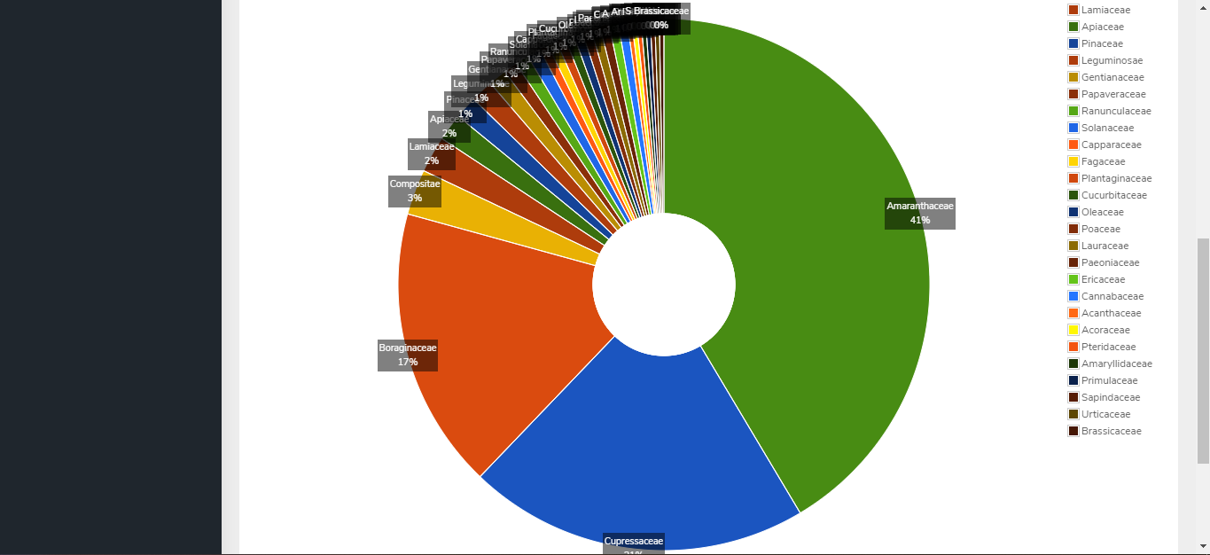

Families with most species found in Albania

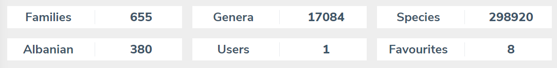

Summary of system data

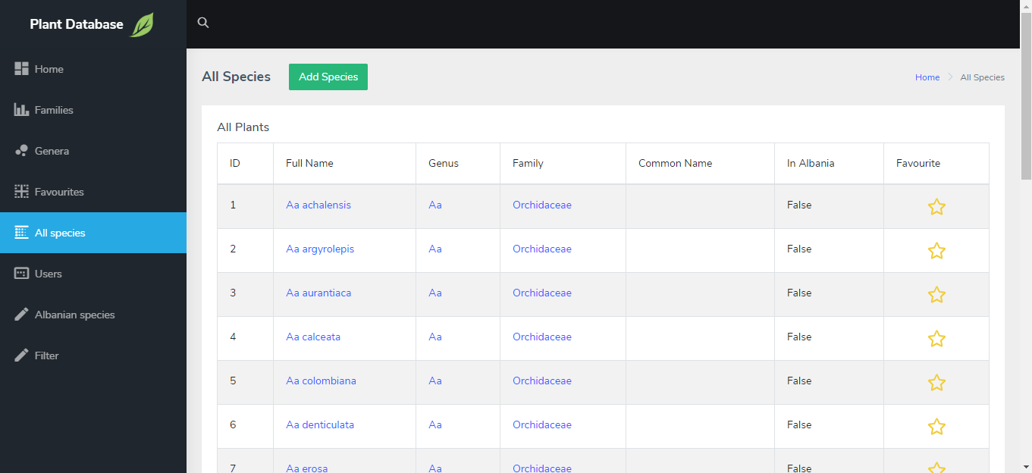

List of all plant species

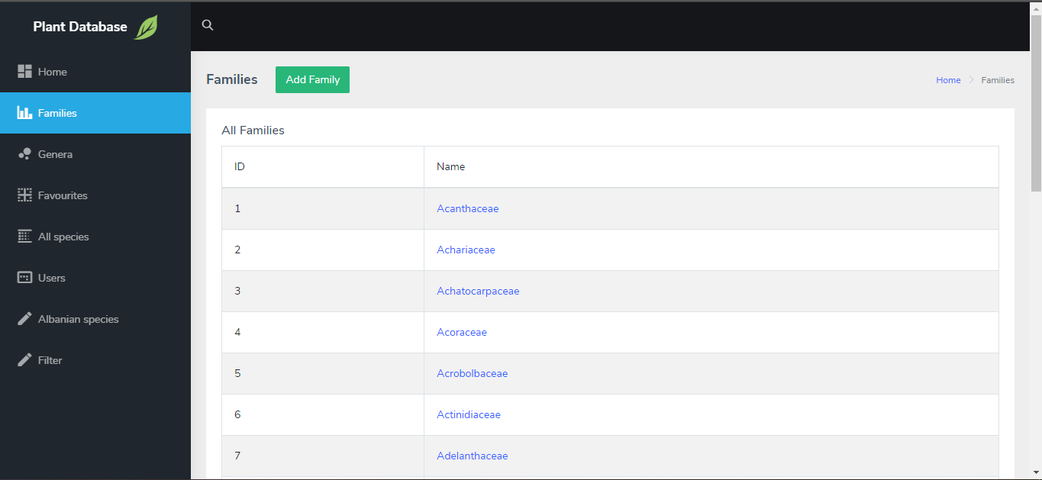

List of all families

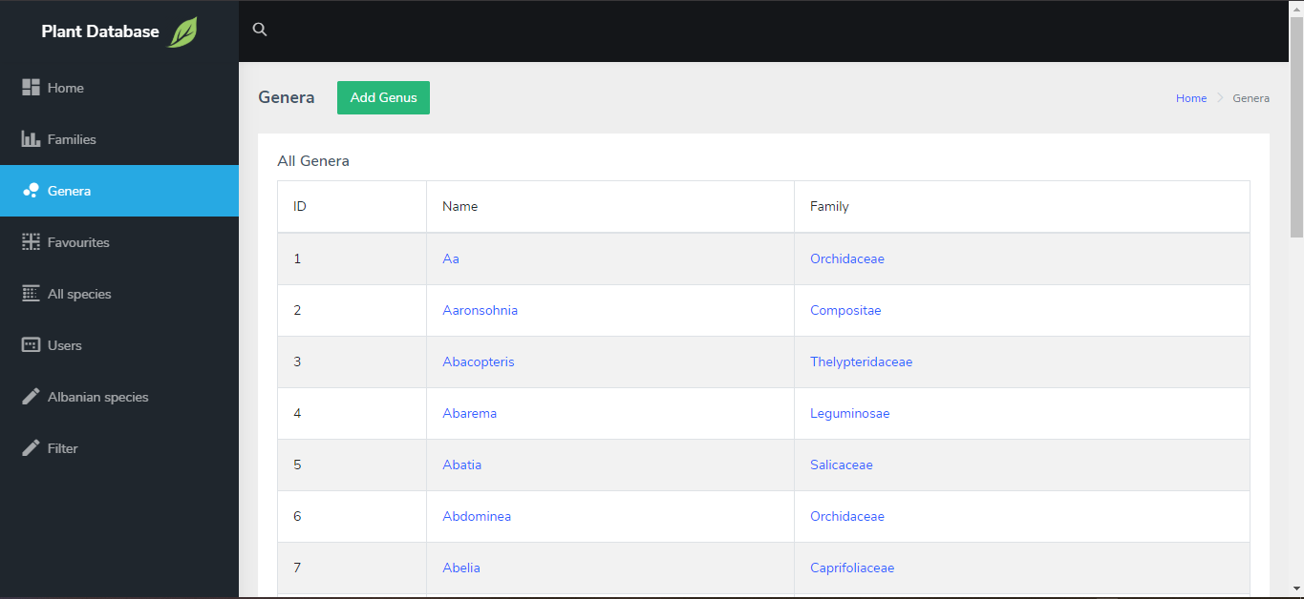

List of all genera

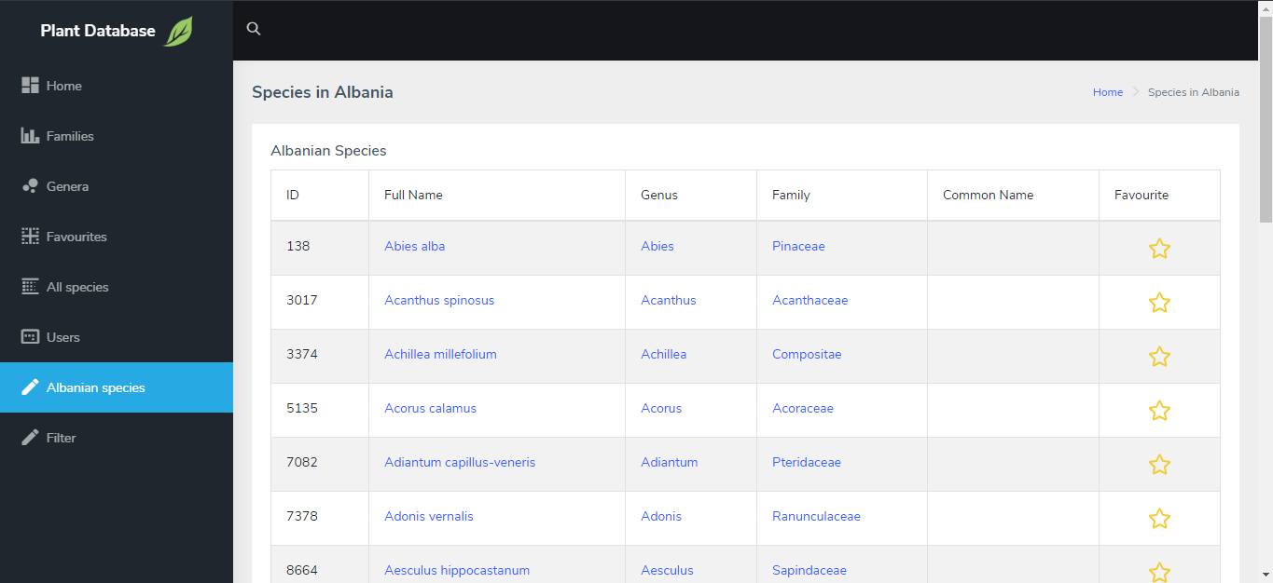

List of all plant species in Albania

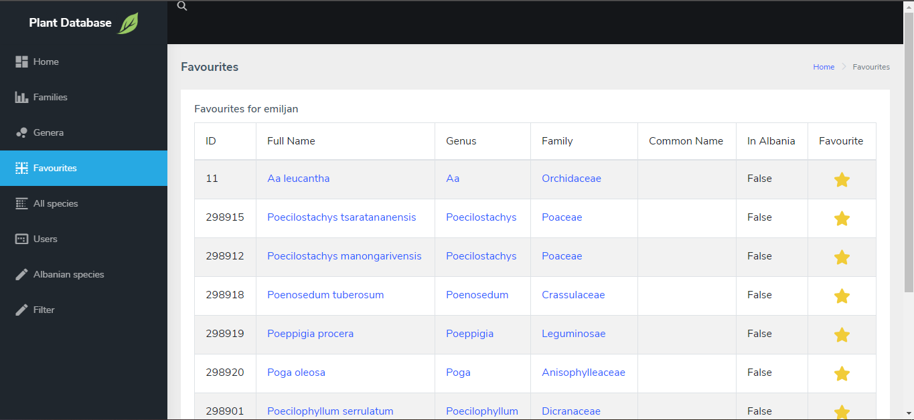

List of favourite plants of the current user

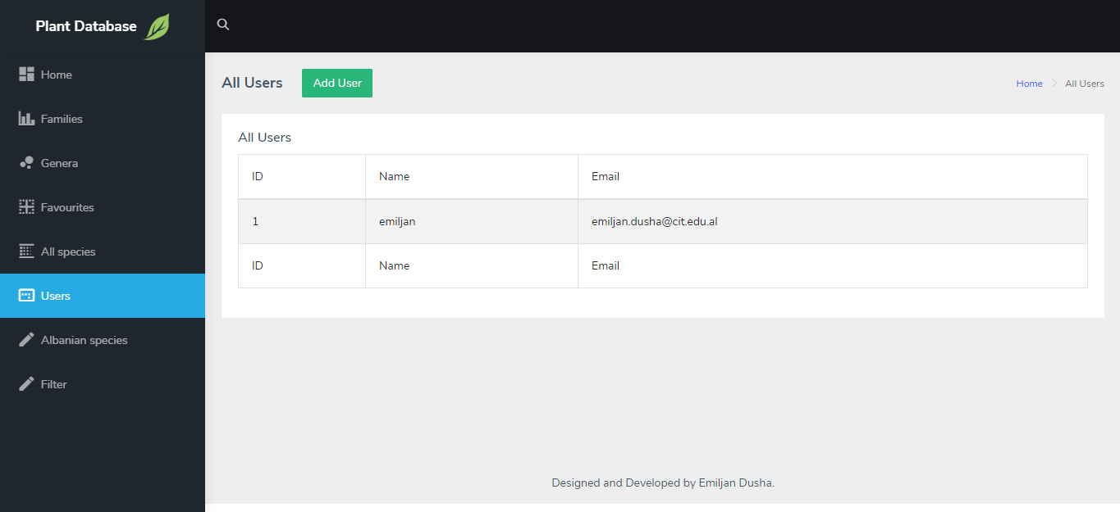

List of all users of the system

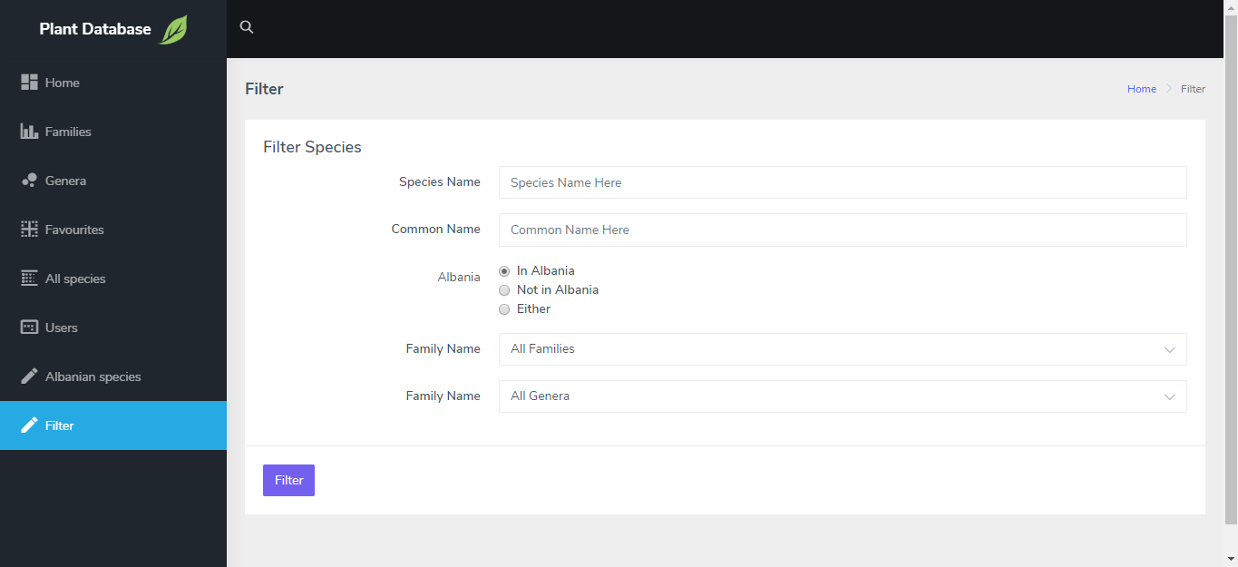

Plant species filter page.